[](https://www.google.com/url?sa=i&rct=j&q=&esrc=s&source=images&cd=&cad=rja&uact=8&ved=2ahUKEwiHxoLxyfnfAhVGMd8KHa7bC1AQjRx6BAgBEAU&url=https://www.certifikid.com/deal/32009/tonchu-martial-arts-academy_-free-uniform-include&psig=AOvVaw1Z0GlRHuBqaNpCeyruqDJh&ust=1547978082129455)

The purpose of this letter is to recommend Isaiah Grissom into the Campbell IB Program.

There are 3 reasons I recommend him:

1. **Isaiah is a Black Belt.**

The Black Belt is a certification that is earned only after committing to a 3 year process of learning, battling and mastering a curriculum designed for Character Development!

The Black Belt creed is:

* Think first of Courtesy and Respect.
* Foster the Spirit of Effort and Immediate Positive Actions.
* Strive for a Better Personality.
* Keep the Way of Sincerity.
* Utilize Knowledge and Physical Vigor for the purpose of Right.

It’s our belief that this type of character development serves as the foundation achieving excellence in School and Life. The Black Belt is held by less than 7 % of people worldwide.

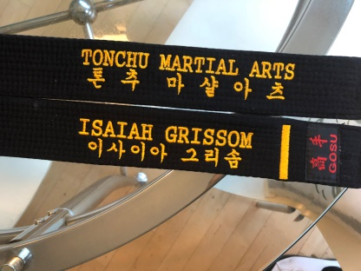

1. **Isaiah’s success skills align with Campbell IB’s success criteria**

As a graduate of the Campbell IB Program, I know what it takes to be successful during those four years of High School.

* Motivation – Will Power.
* Ability – Skill Power.
* Demonstrated Success - Past Power.
* Focus - Super Power.

Isaiah has these success skills and continues to develop himself in these areas. *How do I know?* We’ve tested him each Quarter for 3 years culminating in his Black Belt. Additionally, Isaiah has set a new goal to become a higher ranking Black Belt, which will further refine his skills for success.

1. **Isaiah is an emerging Leader committed to helping others to “get better” too.**

We believe that *Everything Rises & Falls on Leadership*. And so, we lead our students, like Isaiah, to become servant-leaders to their others.

The Leadership creed is:

1. I intend to develop myself in a positive manner and to avoid anything that would reduce my mental growth or my physical health.
2. I intend to develop self-discipline in order to bring out the best in myself and others.
3. I intend to use the skills I learn in class constructively and defensively, to help myself and my fellow man and never to be abusive or offensive.
4. I shall respect my Juniors and Seniors and always abide by the Black Belt Creed.

For these reasons, I believe Isaiah Grissom can succeed at Campbell IB and bring value to the program and student body.

In Excellence,

Jamil Muhammad

Instructor Jamil Muhammad,

Campbell High School Class of 2016

3rd Degree Black Belt

Tonchu Martial Arts

